black box testing

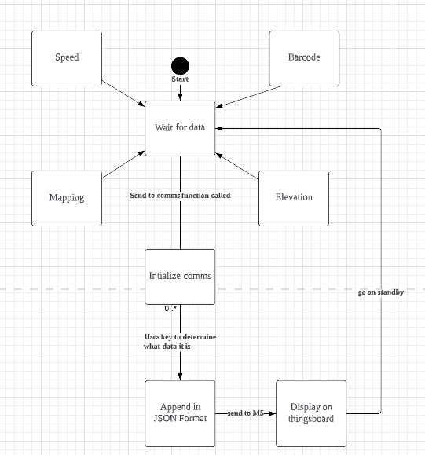

**Sending Elevation/Speed values**

| Causes |  | Values | 1 | 2 | 3 | 4 |
| --- | --- | --- | --- | --- | --- | --- |
| C1 | Key | Y,N | N | N | Y | Y |
| C2 | Value | Y,N | N | Y | N | Y |

| Effects |  |  |  |  |  |  |
| --- | --- | --- | --- | --- | --- | --- |
| C1 | Accept |  |  |  |  | x |
| C2 | Reject |  | x | x | x |  |

**Sending Mapping/Barcode values**

| Causes |  | Values | 1 | 2 | 3 | 4 |
| --- | --- | --- | --- | --- | --- | --- |
| C1 | Key | Y,N | N | N | Y | Y |
| C2 | String | Y,N | N | Y | N | Y |

| Effects |  |  |  |  |  |  |
| --- | --- | --- | --- | --- | --- | --- |
| C1 | Accept |  |  |  |  | x |
| C2 | Reject |  | x | x | x |  |

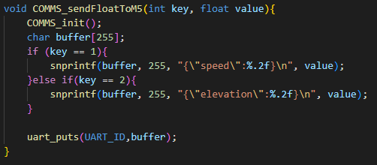

sendFloatToM5 function

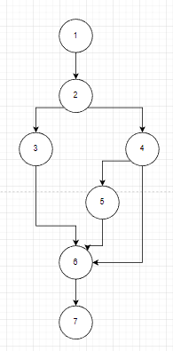

Control Flow Graph for sendFloatToM5 function

| Test Scenario | Test Case | Pre-Conditions | Test steps | Test  Data | Expected Result | Actual Result | Pass/Fail |
| --- | --- | --- | --- | --- | --- | --- | --- |
| Check sendFloatToM5() functionality | Check response upon entering valid key and value in function | sendFloatToM5() must be in main() and setup required dependencies | 1. Enter a key as the first argument in the function  2. Enter a value as the second argument in the function  3. Build all  4. Load .uf2 file into pico | Key:  1  Value: 2.4444 | Value is sent | Value is sent | Pass |
|
| Check response upon entering invalid key in function | Key:  3  Value: 2.4444 | Value is not sent | Value is not sent | Fail |
| Check response upon entering invalid value in function | Key:  1  Value:  “2.4444” | Value is not sent | Value is not sent | Fail |

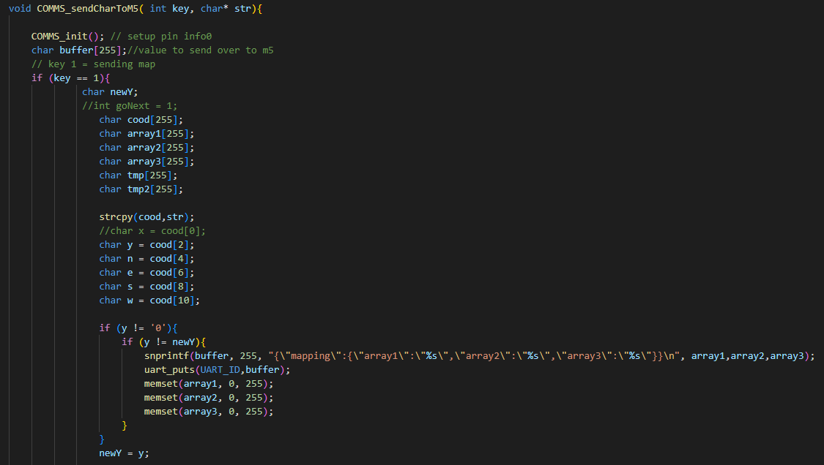

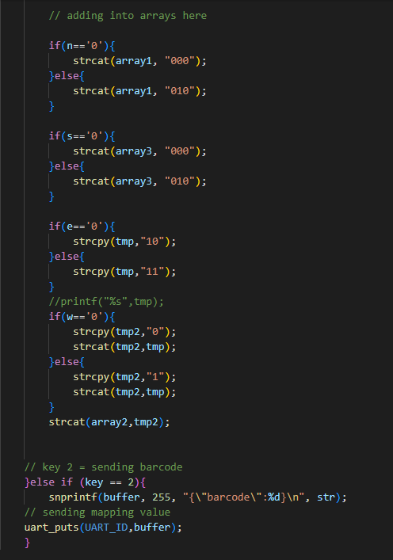

sendCharToM5 function

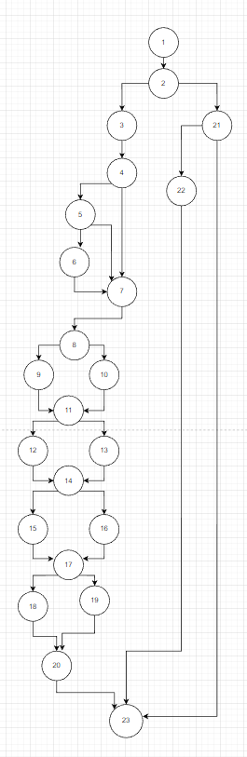

Control Flow Graph for sendCharToM5 function

| Test Scenario | Test Case | Pre-Conditions | Test steps | Test  Data | Expected Result | Actual Result | Pass/Fail |
| --- | --- | --- | --- | --- | --- | --- | --- |
| Check sendCharToM5() functionality | Check response upon entering valid key and value in function | sendCharToM5() must be in main() and setup required dependencies | 1. Enter a key as the first argument in the function  2. Enter a value as the second argument in the function  3. Build all  4. Load .uf2 file into pico | Key:  1  Value:  “0,0,0,1,0,1” | Value is sent | Value is sent | Pass |
|
| Check response upon entering invalid key in function | Key:  3  Value: “A” | Value is not sent | Value is not sent | Fail |
| Check response upon entering invalid value in function | Key:  2  Value:  3 | Value is not sent | Value is not sent | Fail |